Sommerlyst's
Zu-Ba Norbu
Born 29.01.2009
Sable
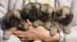
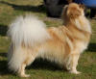
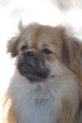
 | DKCH Sommerlyst's A-Ba Kham-Pa  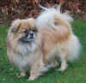  Sable  Born 25.8.02 | Xselti V.H.Falconsnest  Sable | Toyway Gari-Baldi  Sable
 |  | Xselti V.H.Falconsnest  Sable | CH Sommerlyst's Shanie So Ma Sable
 |  | Sakya's Selda Milli-Enium  Sable | CH Sagaland's Mescal  Sable
 |  | Sakya's Selda Milli-Enium  Sable | CH Jotono's Suzi  Sable
 | INTCH EICH GBCH DKCH Cruftvinder  Avigdor Julietta    (Zara)  Zobel | Glishanna Troy | CH Deanford Poseidon
 |  | Glishanna Troy | CH Avigdor Olympia
 |  | EICH  Avigdor Jussia | CH AVigdor Uisean
 |  | EICH  Avigdor Jussia | CH Avigdor Jussina

